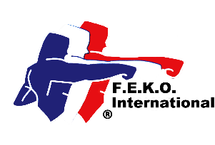


Federation of English Karate Organisations International
In direct membership to
the World Union of Karate-Do Federations

Federation of English Karate Organisations
Federation of Martial Arts

in direct membership to the World Kobukan Federation

www.feko.co.uk E-mail: jim@feko.co.uk

Jim Reece, Hon-Secretary, 234 West Park Drive West, Roundhay, Leeds LS8 2BD. Tel 07940 565046

FMA Annual Association Membership 2026
Complete all parts

Association

Contact name

Position

Address

Post code Tel No Mobile No

E-mail Web site

Do you want your website linked to the FEKO website? Yes ☐ No ☐

Chief Instructor’s name

Address

Post code Tel No Mobile No

E-mail Grade

☐ I enclose a cheque for £50.00 for continued Federation membership

☐ I have transferred £50.00 by BACS directly into the FEKO International Account

☐ I enclose a *cheque for £ 100.00/*. I have transferred by BACs the sum of £100.00 for lapsed membership and the reinstatement of my Association and individual members’ insurance coverage. (Maximum time limit 3 months). (*delete as necessary). Without the membership renewal payment, all insurance coverage ceases on 31 January 2026 and is only reactivated from receiving the late payment.

All Instructors must have Instructor Indemnity Insurance, be registered under the Federation’s Safeguarding Child & Vulnerable Adult Protection Policy, have an enhanced DBS clearance certificate and a first aid certificate.

Signed Date

Print name: Position

Please make all cheques payable to FEKO International. A registration certificate will be issued. Send to Jim Reece at the above address.
Official use only. Date received. Fee enclosed £ Date certificate issued.

