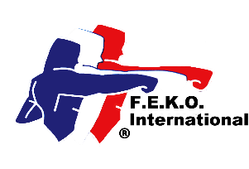


Federation of English Karate Organisations International
In direct membership to
the World Union of Karate-Do Federations

Federation of English Karate Organisations
Federation of Martial Arts

in direct membership to the World Kobukan Federation

www.feko.co.uk E-mail: jim@feko.co.uk

Jim Reece, Hon-Secretary, 234 West Park Drive West, Roundhay, Leeds LS8 2BD. Tel 07940 565046

FEKO Affiliate Membership 2026
Complete all parts.

Association

Contact name

Position

Address

Post code Tel No Mobile No

E-mail Web site

Do you want your website linked to the FEKO website? Yes ☐ No ☐

Chief Instructor’s name

Address

Post code Tel No Mobile No

E-mail Grade

☐ I enclose a cheque for £50.00 for continued Federation membership

☐ I have transferred £50.00 by BACS directly into the FEKO International Account

☐ I enclose a *cheque for £ 100.00/*. I have transferred by BACs the sum of £150.00 for lapsed membership and the reinstatement of my Association and individual members’ insurance coverage. (Maximum time limit 3 months). (*delete as necessary). Without the membership renewal payment, all insurance coverage ceases on 31 January 2026 and is only reactivated upon receipt of the late payment.

Insurance requirements: All Instructors must have Instructor Indemnity Insurance, be registered under the Federation’s Safeguarding Child & Vulnerable Adult Protection Policy, have an enhanced DBS clearance certificate and a first aid certificate.

Signed Date

Print name: Position

Please make all cheques payable to FEKO International. A registration certificate will be issued. Send to Jim Reece at the above address. Official use only. Date received. Fee enclosed £ Date certificate issued.

